DROP LINK SERIES 7/16 UNF

PART NUMBER | LENGTH
1800071 | 150MM
1800072 | 200MM
1800073 | 250MM
1800074 | 300MM
1800075 | 350MM
1800076 | 400MM
1800077 | 450MM
1800078 | 500MM

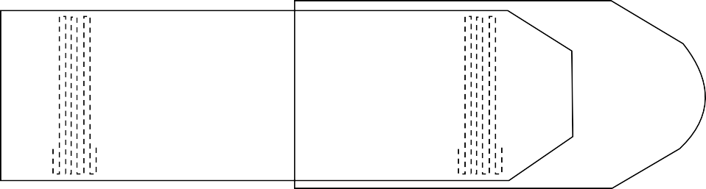
150mm – 500mm

